Research Report Data Screening Technology Spark Living Lab

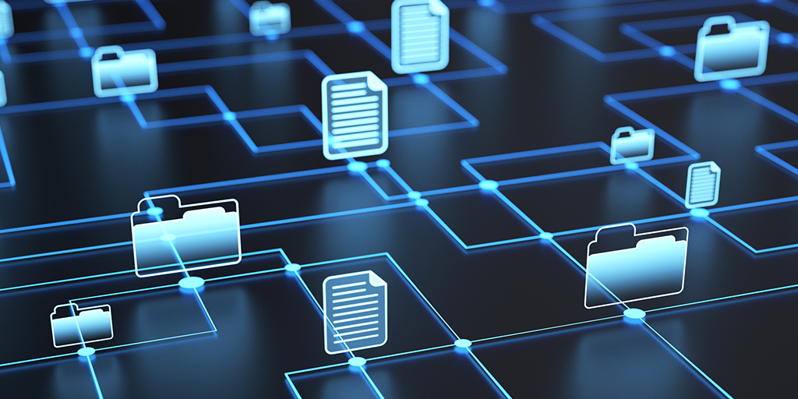

***Students****: Kaan Erdem*

*Jocelyn Maufrand*

Topics

1. Introduction 3

1.1 School side of the project 3

2. Problem Analysis 4

2.1 The context 4

2.2 The reason for the project 4

2.2.1 For whom is the project urgent/ needed? 4

3 Describing the impactful technologies 5

3.1 Blockchain 5

3.1.1 Gartner’s Maturity Model (level two): 11

3.2 Internet of Things 12

3.3 Artificial Intelligence 18

18

3.3.1 Basics of AI 18

3.3.2 Three different types of AI: 18

3.3.3 Examples of AI used nowadays 18

3.3.4 Gartner Maturity Level 18

3.4 Big Data 20

3.4.1 Structured Data 20

3.4.2 Unstructured Data 21

3.4.3 Semi-structured Data 22

3.4.4 How do we know that the data is big data? 22

3.4.5 Gartner’s Maturity Model & Swot Analysis 23

3.5 API 25

3.5.1 How do APIs work? 25

3.5.2 APIs in Supply Chain 25

3.5.3 Business’ & API System providers 25

3.6 Cloud Computing 27

3.6.1 Benefits of Cloud Computing 27

3.6.2 Cloud Computing in Supply Chain 27

3.6.3 Summary 27

4 Use Cases 29

4.1 Walmart & Blockchain Implementation 29

4.1.1 Case summary 29

4.1.2 The challenge 30

4.1.3 The situation before the implementation of Blockchain 30

4.1.4 The situation after the implementation of Blockchain 30

4.1.5 Conclusion: 31

4.2 Disneyland Case 32

4.2.1 Summary of the case: 32

4.2.2 The challenge 33

4.2.3 The situation before the MM+ implementation 33

4.2.4 The situation after the implementation 34

*4.2.5 Conclusion*: 36

5 The end conclusion of the project 37

Bibliography 39

**Attachments** 40

Attachment 1 Articles 40

Attachment 2 Extra Cases 40

Attachment 3 Proof of Concept 40

Attachment 4 Technology Providers List 40

**Figure List** 41

# 1. Introduction

## 1.1 School side of the project

This school project is conducted by Kaan Erdem and Jocelyn Maufrand who all of them studied for this semester at Windesheim University of Applied Sciences. This project aims to build up a benchmark about the new technology used in Supply Chain by the companies. The module to which this project belongs is Project Supply Chain Engineering (EDPSCE). The internship period for the academic year 2021/2022 started on 7 September 2021 and will end in January 2022. This agreement is that two days per week are spent on the project assignment. For the project assignment, we must eventually hand in a short report.

**Organization:**

Sparklivinglab is a structure that regroups students, teachers, and manufacturers to find what kind of new technology could be used in logistics and Supply chains today and in the future. This research is divided into six parts:

* Track and Trace: Insight into reliable and accurate delivery times, origin, and certification at the product level is the holy grail of the logistics sector.
* Progress integration: Improve procure-to-pay and order-to-cash processes by using reliable and accurate digital transport and export documents.
* Digital twins: A digital product passport with product information to be used by the entire chain offers all kinds of possibilities for sustainability.
* Checking shelf life and quality: The real-time monitoring and execution of an SLA around conditioned (e.g., refrigerated) transport is still limited by the available information.
* Secure data exchange: The secure exchange of reliable information is crucial. While maintaining a level playing field for all participating parties, open and inclusive.
* Paper progresses: Paper documents play a major role in exports. How can these be digitized without the risk of fraud? And what does this mean for automatic execution?

# 2. Problem Analysis

## 2.1 The context

Spark Living Labs is a co-creation of business, research, and education that helps companies improve their supply chain by implementing different kinds of data-driven technologies. They can also provide great help in optimizing logistics or circular economy, which a lot of companies are struggling with nowadays. Spark Living Labs ensures that the company gets the right implementation of technology and at the same time still be as productive or even more productive than before.

## 2.2 The reason for the project

This research project is part of the research program Sustainable Living Labs, which is co-financed by the Dutch Research Council (NWO), the Ministry of Infrastructure and Water Management, Taskforce for Applied Research (SIA), and the Top Sector Logistics. The main goal is to explore the application of data-sharing technologies in supply chains and logistics.

### 2.2.1 For whom is the project urgent/ needed?

#### Vision on the subject

Spark Living Labs sees that the demand for well data-driven technologies is high, to make sure that companies join along in this journey, they have set up physical hubs where it is possible to experiment with data-driven technologies and IoT (Internet of Things) and prepare for future working environment. Besides Spark, the companies that join the project benefit from it as well, since the government has set a goal for 2050 to be emission-free and sustainable. If the project rolls out well then three parties benefit from this project.

# 3 Describing the impactful technologies

## 3.1 Blockchain

In the past times when people lived closer to each other in a small community, it was easier for them to trade within their groups, but as the distance in their exchanges increased, they eventually invented institutions. If we use Uber, Airbnb, or Amazon even these are just digital marketplaces and platforms that help us facilitate an exchange of value.

However, today we have a technology that allows us to trade one-to-one but at a scale that is called Blockchain technology. There are certain interfaces created to access this system. You could have an app, or you could use your computer to do it but instead of having a company as a mediator or more specifically a third party that can help you to make the transaction, there is a lot of software code involved and they run by all these different computers that create a node. Node is simply a computer connected to other computers in this system that follows rules and shares information. Node’s other point is also to verify each transaction and make sure that the information on the blocks is correct. They all use the same software and guarantee your transactions as they happen.

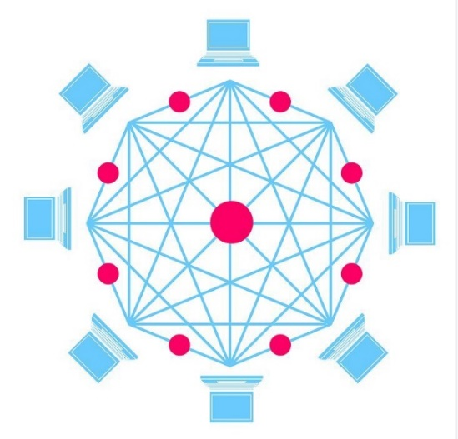

Figure 1 Blockchain Model (Dughi, 2018)

Figure 2 Blockchain Model (Dughi, 2018)

Many people in the financial industry are looking at it from a banking side, wondering how to use this technology to do business like Bitcoin or other tokens that are easier to use instead of today’s currency. The vast majority of people think about Blockchain as Bitcoin because the media often talks about it, since it is one of the popular cryptocurrencies. However, we can notice that there are a lot more use cases for Blockchain that aren’t around the currency side but more around how do you take any asset and be able to trade that using the same technology.

Today, a lot of people are working on how to create identity structures that leverage blockchain, and one of the tools for doing that is being able to cryptographically assign for a given attribute. For example, your government could affirm that you have a passport from the Netherlands, or a university could sign that you are a currently enrolled student. Therefore, you could then dole out that information and control it yourself and be able to show people those certifications on an as-needed basis.

If we go into more detail to see how it works, here's what we have. Each block contains data, the hash of the block, and the previous block’s hash.

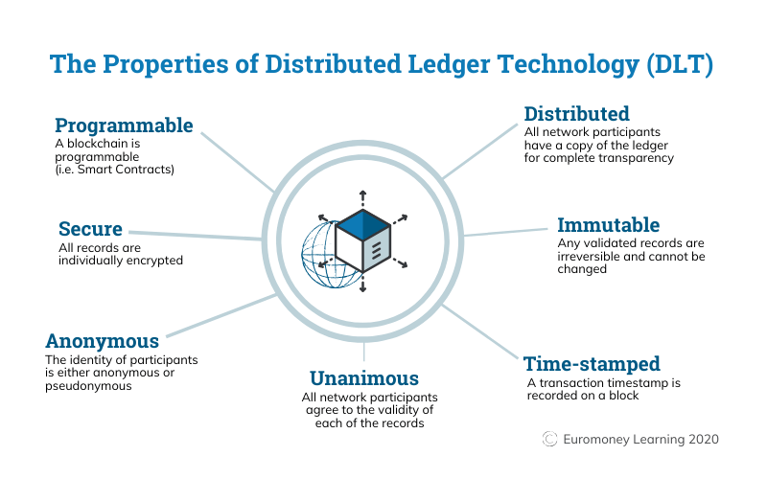

Figure 3 The Properties of Distributed Ledger Technology (DLT) (Writer, 2021)

The data stored is not the same from one block to another: it is specific to the type of blockchain used. For Bitcoin, for example, the information contained in the Blockchain is related to the person who sends the money, the person who receives it, and the amount that is transferred. In addition, each block contains a hash that defines its own identity. No matter what block is considered unique. The hash of a block is calculated each time a block is produced. As a result, modifying its contents will result in a change in the hash. To put it another way, hashes are extremely valuable for determining if a single block has been manipulated or not because if a hash is modified, the block associated with it is not the same anymore. The third element that the block contains is the hash of the previous block. It is with this last information that the blockchain is formed. This third piece of information guarantees the security of the blockchain.

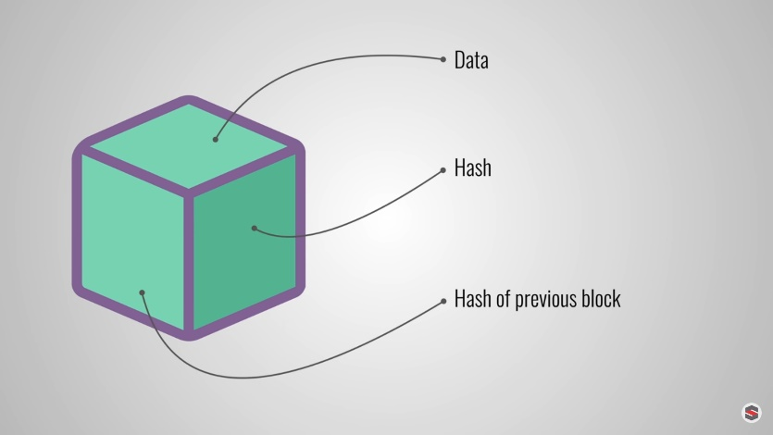

Figure 4 Informations included in a block (Explained, 2017)

For example, three blocks are enough to create a blockchain. Each of the blocks includes the hashes of the previous blocks. Not all blocks refer to another block, it is just the case for the primary block. The primary block, called the "genesis" block, cannot refer to a previous block since it is the first block.

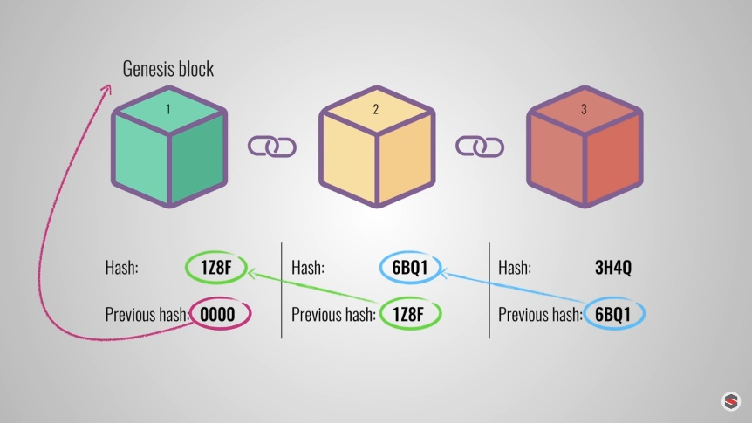

Figure 5 Link between blocks (Explained, 2017)

If changes are made to the second block, this conjointly causes the block to be hashed. This results in a multitude of problems within the blockchain specifically the invalidation of the block of rank three as well as each of the following blocks, as they do not have the valid hash of the previous block. Therefore, the modification of a single block will invalidate all subsequent blocks. However, given the speed of today's computers, hashing is limited in its action against tampering. Computers can process several thousand hashes per second. To limit the fact that it is possible to create a block and recalculate all the hashes of the following blocks, a system called "proof of work" has been put in place for blockchains.

The "proof of work" is a mechanism that delays the creation of additional blocks to the initial blockchain. As an example, regarding Bitcoins, it takes about ten minutes to calculate the "proof of work" and accordingly add a new block to the chain. This system makes it very hard to regulate blocks. That means in case changes are made to a block, the "proof of work" will have to be recalculated for all the following blocks. Consequently, the security of a blockchain comes from its creative use of hashing and the "proof of work" mechanism.

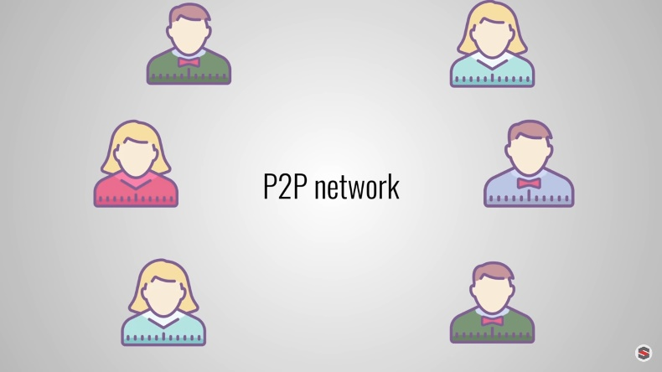

Figure 6 Peer to peer network (Explained, 2017)

At the same time as this system protects against falsification of the blockchain, this data-sharing technology can be secured in other ways, along with through their distribution. As opposed to the usage of a principal entity to run the chain, blockchains use a peer-to-peer network that all and sundry can belong to. When a person joins this network, he or she gets the full copy of the blockchain the node can use this copy to check that everything is still in order. If someone generates a new block, it is sent to all members of the network. Every node then checks the block to make sure it has not been corrupted. If the whole thing is right, every node adds this block to its blockchain.

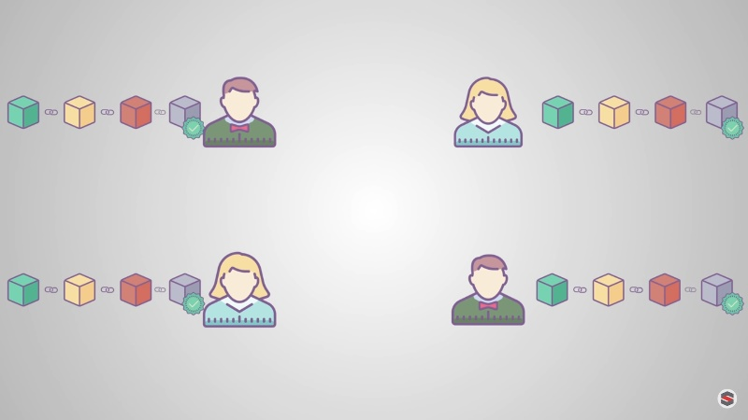

Figure 7 Everyone possess the data (Explained, 2017)

An agreement is thus created between all the nodes in the network, which means that they agree on which blocks are correct and which are not. If the blocks are not correct, all the nodes will remove these blocks from the network. Thus, to successfully falsify a blockchain, we would have to change all the blocks on the chain, redo the "proof of work" for each block and control more than 50% of the network. A falsified block can only be accepted by everyone from that moment on. So, it is almost impossible.

Furthermore, blockchains are continuously evolving. One of the most recent developments is the introduction of smart contracts. These are simple programs that are stored on the blockchain and can be used to robotically change coins primarily based on specific situations.

Some of the upcoming blockchains are listed below:

* HYPERLEDGER
* Created by Linux.
* It is a central organisation, that includes various blockchains.
* Open-source projects and develops solutions for enterprises.
* Blockchain networks developed using Hyperledger architecture are private and permissioned.
* ENTERPRISE ETHEREUM
* Is built on the Ethereum codebase, but it is a private and permissioned implementation.
* Ethereum Alliance rules this blockchain.
* Permissioned & highly customizable.
* CORDA
* Puts a strict emphasis on the privacy of transactions.
* Only the peers that are a party to a transaction can view the transaction data.
* Smart contracts can be written in JVM languages and Java.
* Permissioned.
* QUORUM
* Quorum is founded by JP Morgan.
* It is a fork of the Ethereum blockchain platform.
* Permissioned and private to enable users to transact in confidence.
* It enhances trust through users validating signatures of other peers; does not support anonymous transactions.
* OPENCHAIN
* It is a standalone software that departs from the traditional design of blockchain platforms.
* Information is stored in blocks that are arranged in chains linked directly.
* Transaction validation is done centrally.
* Every node manages its ledger completely.

|  |  |  |  |  |  |
| --- | --- | --- | --- | --- | --- |
|  | HYPER LEDGER | ENTERPRISE ETHEREUM | CORDA | QUORUM | OPENCHAIN |
| Transactions per second | *3500 TPS*  <https://www.ibm.com/blogs/research/2018/02/architecture-hyperledger-fabric/> | *15 to 25 TPS*  [*https://alephzero.org/blog/what-is-the-fastest-blockchain-and-why-analysis-of-43-blockchains/*](https://alephzero.org/blog/what-is-the-fastest-blockchain-and-why-analysis-of-43-blockchains/) | *15 to 1678 TPS*  [*https://www.corda.net/blog/transactions-per-second-tps/*](https://www.corda.net/blog/transactions-per-second-tps/) | *Dozens to Hundreds TPS*  [*https://github.com/ConsenSys/quorum-docs/blob/master/Quorum%20Whitepaper%20v0.1.pdf*](https://github.com/ConsenSys/quorum-docs/blob/master/Quorum%20Whitepaper%20v0.1.pdf) | Thousands TPS  <https://docs.openchain.org/en/latest/general/anchoring.html> |
| Security | / | / | / | / | / |
| Maintenance | / | Ethereum Blockchain Maintenance Services <https://www.leewayhertz.com/ethereum/maintenance-and-upgrade/> | Node Maintenance Mode (Perform RPC Audit table cleanup and  Run message ID Cleanup)  <https://docs.r3.com/en/platform/corda/4.7/enterprise/node/operating/maintenance-mode.html> | / | / |

### 3.1.1 Gartner’s Maturity Model (level two):

You can add new information that is more current, but you can't delete anything. The way technology is evolving shows us that nothing will be the same as it was before. With this kind of technology, we will certainly have to rewrite a lot of the rules in economics because a lot of the assumptions will no longer hold, like who are the actors, they are not just people anymore, they are machines. So, we'll have to create entirely new concepts about how they trade and work with us.

Also, there are trust issues. Indeed, there have been hacks and so there is a need to work on trust and the feeling that this is a safe technology. For example, one of the problems that Bitcoin faces is the theft or loss of Bitcoins. However, this is mostly from people trying to resell bitcoins in a different way, which makes them easy targets. Education is going to be a big part of it before we can use technology in a broad sense. Indeed, to transition to this innovation and make it useful for ordinary people, we're going to have to make sure that we have a lot more education, a lot more standards, and probably work with a lot of companies to create a user experience around this technology that is safe but needs to be usable and understandable by everyone.

At the moment, this technology is still in a state of research and is being developed for application in many areas. It could be used almost everywhere but we don't know yet where it's all going to go. We have a lot of public blockchains like Bitcoin, Ethereum, Network NXT, whereas they are starting to appear in a more professional setting. A lot of companies and consortia are coming together to build private blockchains, more closed at first, which will evolve later. For example, projects in energy, in pharmaceuticals, in retail, and a lot of different fields are starting experiments and we'll see in the next few years how all of that interacts and we'll learn about the best use cases for blockchain and what that means for commerce.

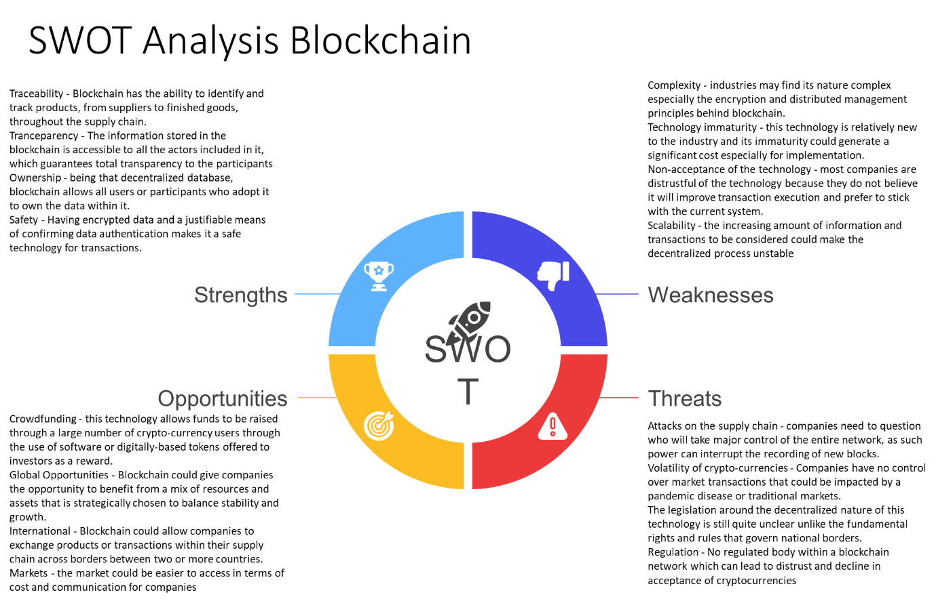

Figure 8 SWOT Analysis Blockchain

The subject of this article is blockchain. The purpose of this article is to present very quickly different points to know about this technology of information sharing. This means in particular the strengths, the weaknesses as well as opportunities that revolve around the blockchain

## 3.2 Internet of Things

Until recently, access to the internet was limited by devices like the desktop, tablet, or smartphone, but with the internet of things (IoT), virtually any device can be linked to the internet and controlled from a distance. Thus, the IoT helps us better understand how things around us work. So, the Internet of Things is a system of interdependent devices connected to the internet to transfer and receive data from one to another.

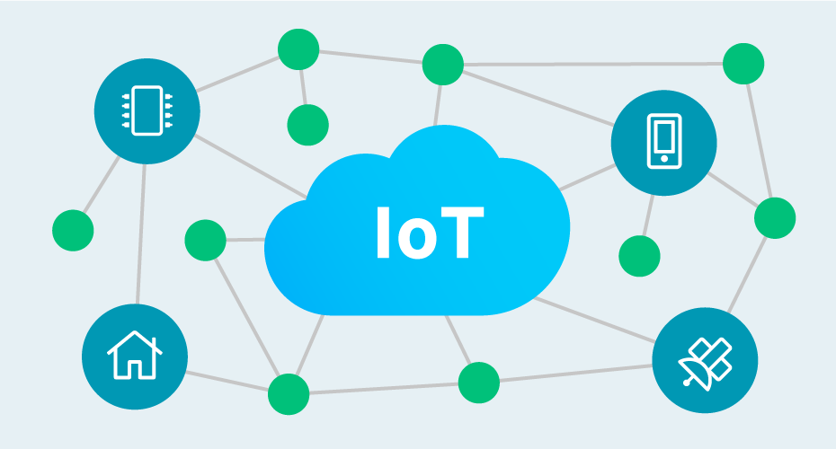

Figure 9 IoT Model (Zilverline, 2020)

A smart home is perhaps the most striking example for everyone at the moment. Home appliances such as air conditioning, doorbell, thermostats, smoke detectors, water heaters, and security alarms can be interconnected to share data with the user via a mobile app. The user can now get a detailed overview of the operation of the devices around them. Until recently, using the internet allowed people to connect and interact with each other, but now electronic objects can sense their surroundings to interact and collaborate.

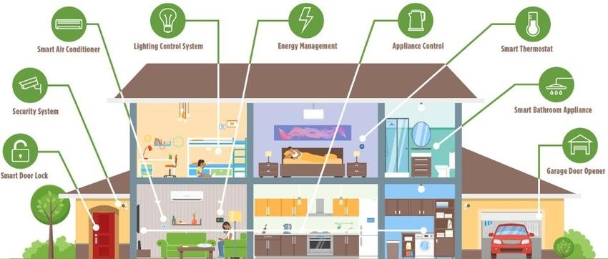

Figure 10 Iot in the house (Oukrich, 2019)

For example, in the morning when our alarm goes off, the IoT system can open the window blinds, turn on the coffee maker for us, and even turn on the water heater. While all of this is fascinating, a lot is going on in the background to keep the system running smoothly, from making communication more efficient between devices to processing the data more accurately. Many components are involved.

In the context of IoT devices, hardware can be classified into general devices and sensing devices. If we look at the general devices, they are the main components of the information exchange and data hubs. They have connected either wired or wireless interfaces. Home appliances are classic examples of these devices. The sensing devices are composed of sensors and actuators. They measure temperature, humidity, light intensity, and other parameters.

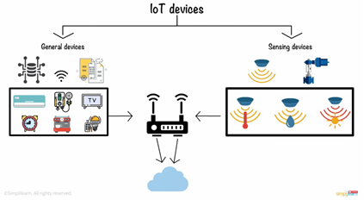

Figure 11 IoT devices (Simplilearn, 2020)

These IoT devices are connected to the network using gateways. These gateways or processing nodes process the information collected by the sensors and transfer it to the cloud. The cloud acts as both a storage and processing unit. Actions are performed on the collected data for further learning and inference. Wired and wireless interfaces such as Wi-Fi, Bluetooth, ZigBee, GSMS, etc. are used to provide connectivity. To ensure ubiquity, applications must support a diverse set of devices and communication protocols, from small devices capable of detecting and reporting the desired factor to powerful back-end servers used for data analysis and knowledge extraction.

If we go into a little more detail to see how this works, we can take a simple scenario. We imagine that our goal is to water our garden every time the soil moisture level drops. Instead of doing it manually, we could automate it using IoT. The installed sensor and actuators gauge the soil for its moisture. This information is then sent to the IoT gateway using communication protocols such as MQTT or HTTP. The gateway aggregates the data in a meaningful way and transmits it to the cloud using a Wi-Fi network. Once the humidity level drops, the system is immediately triggered, and the sprinklers are activated.

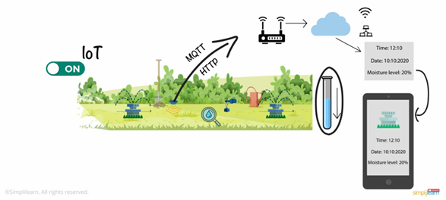

Figure 12 IoT and automatic soil watering (Simplilearn, 2020)

However, with the information stored in the cloud, detailed analysis can be done such as the time the sprinkler was activated, the rate of soil moisture reduction, etc., and the report can be sent to our smartphone via an app. With the improved response, monitoring, and analysis capabilities, the Internet of Things is being adopted in almost every industry and field, opening the door to endless applications.

The manufacturing industry has already taken with open arms the IoT system. Many menial jobs are already automated. IoT even not only increases interactivity but also boosts efficiency and production as well in this industry. As an example of an application in industry, we can take the port of Rotterdam. It's a port that stretches for about 50 kilometers, has 3,000 companies, carries 470 million tons of cargo, and employs about 385,000 people. It is located in a special climatic environment. Every day the tide is different, there is a lot of wind, all of which has an impact. Thus, the port's leaders decided that it needed digital transformation to survive. Building the world's smartest port is one of their main objectives.

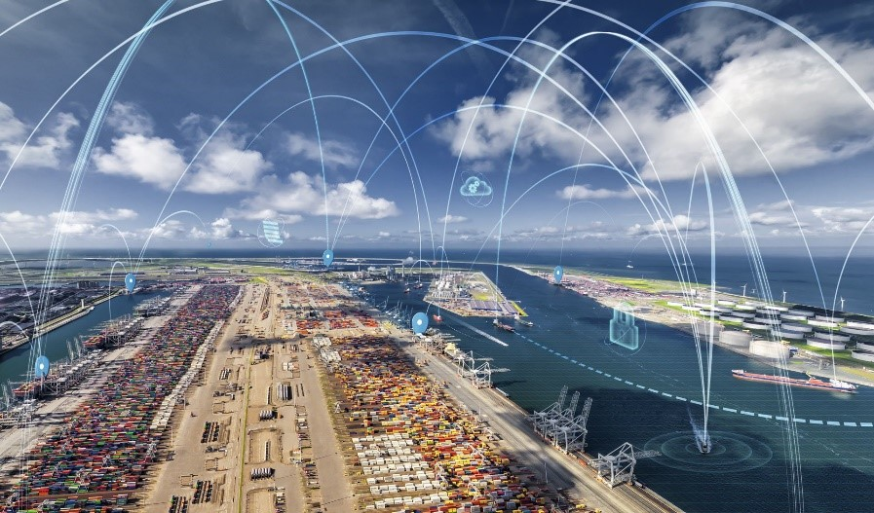

Figure 13 IoT in the industry (Hamblen, 2018)

First, they are using AI to have a digital twin of the port. This digital twin is a digital representation of the port and all assets within the port become intelligent. They need IoT centres to do that. IoT sensors are very diverse. They measure a lot of parameters relevant such as water movement, tidal height, vibration, pressure, motion, temperature, water turbidity.

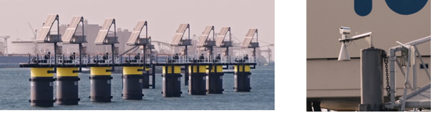

Figure 14 Examples of sensors in the port of Rotterdam (IBM Industries, 2019)

With these sensors, people have a better idea of how the different assets and equipment in the harbour work with each other. If you can start digitizing everything from cranes to ships to quay walls and derive real-time information from that, decisions can be made extremely quickly and with much better accuracy.

If we go into a little more detail, the technology used in the control room is IBM's hydrometeorological dashboard. They look at the information on tidal currents, salinity, visibility, wave height, wind, wind direction. This data helps those in charge of guiding ships safely into port.

3.2.1 Gartner’s Maturity Model (level 3) & Swot Analysis:

As we have noted, Internet of Things technology has many benefits, whether it's being able to monitor a shipment anywhere or perform surgery remotely in the future. However, there are still many barriers to the widespread adoption of IoT and the establishment of a secure and functional global network of devices.

First, in terms of cybersecurity, IoT devices have a greater amount of potentially hackable areas for cybercriminals than other technologies putting at risk in a secure network. In 2017, a casino's data was compromised by hackers who accessed its network via an IoT thermostat in one of its fish tanks.

Another common characteristic of technological innovations is that government regulation often takes a long time to establish rules for the current state of technology. This is the case with the rapid evolution that is occurring in IoT as companies are often left without the critical information, they need to make decisions.

We know that with this type of technology, there is a lot of competition. This can be good news, as competition creates more choices for consumers, but it can also create compatibility issues. For example, home mesh networks are one area where compatibility issues loom. Indeed, there are several competitors to Bluetooth, such as Zigbee and Z-Wave. We could be years away from a market that is large enough to implement a single universal standard for home IoT.

Connectivity is also a very important challenge for IoT. Indeed, as the size of the IoT market grows exponentially, some experts fear that bandwidth-intensive IoT applications, such as video streaming, will soon have no place on the current server-client model of IoT. Indeed, the server-client model uses a centralized server to verify and direct traffic on IoT networks. However, as more and more devices begin to connect to these networks, they often struggle to handle the load. So, it's important for IoT companies to carefully consider their IoT connectivity providers and choose one with a strong history of service and innovation.

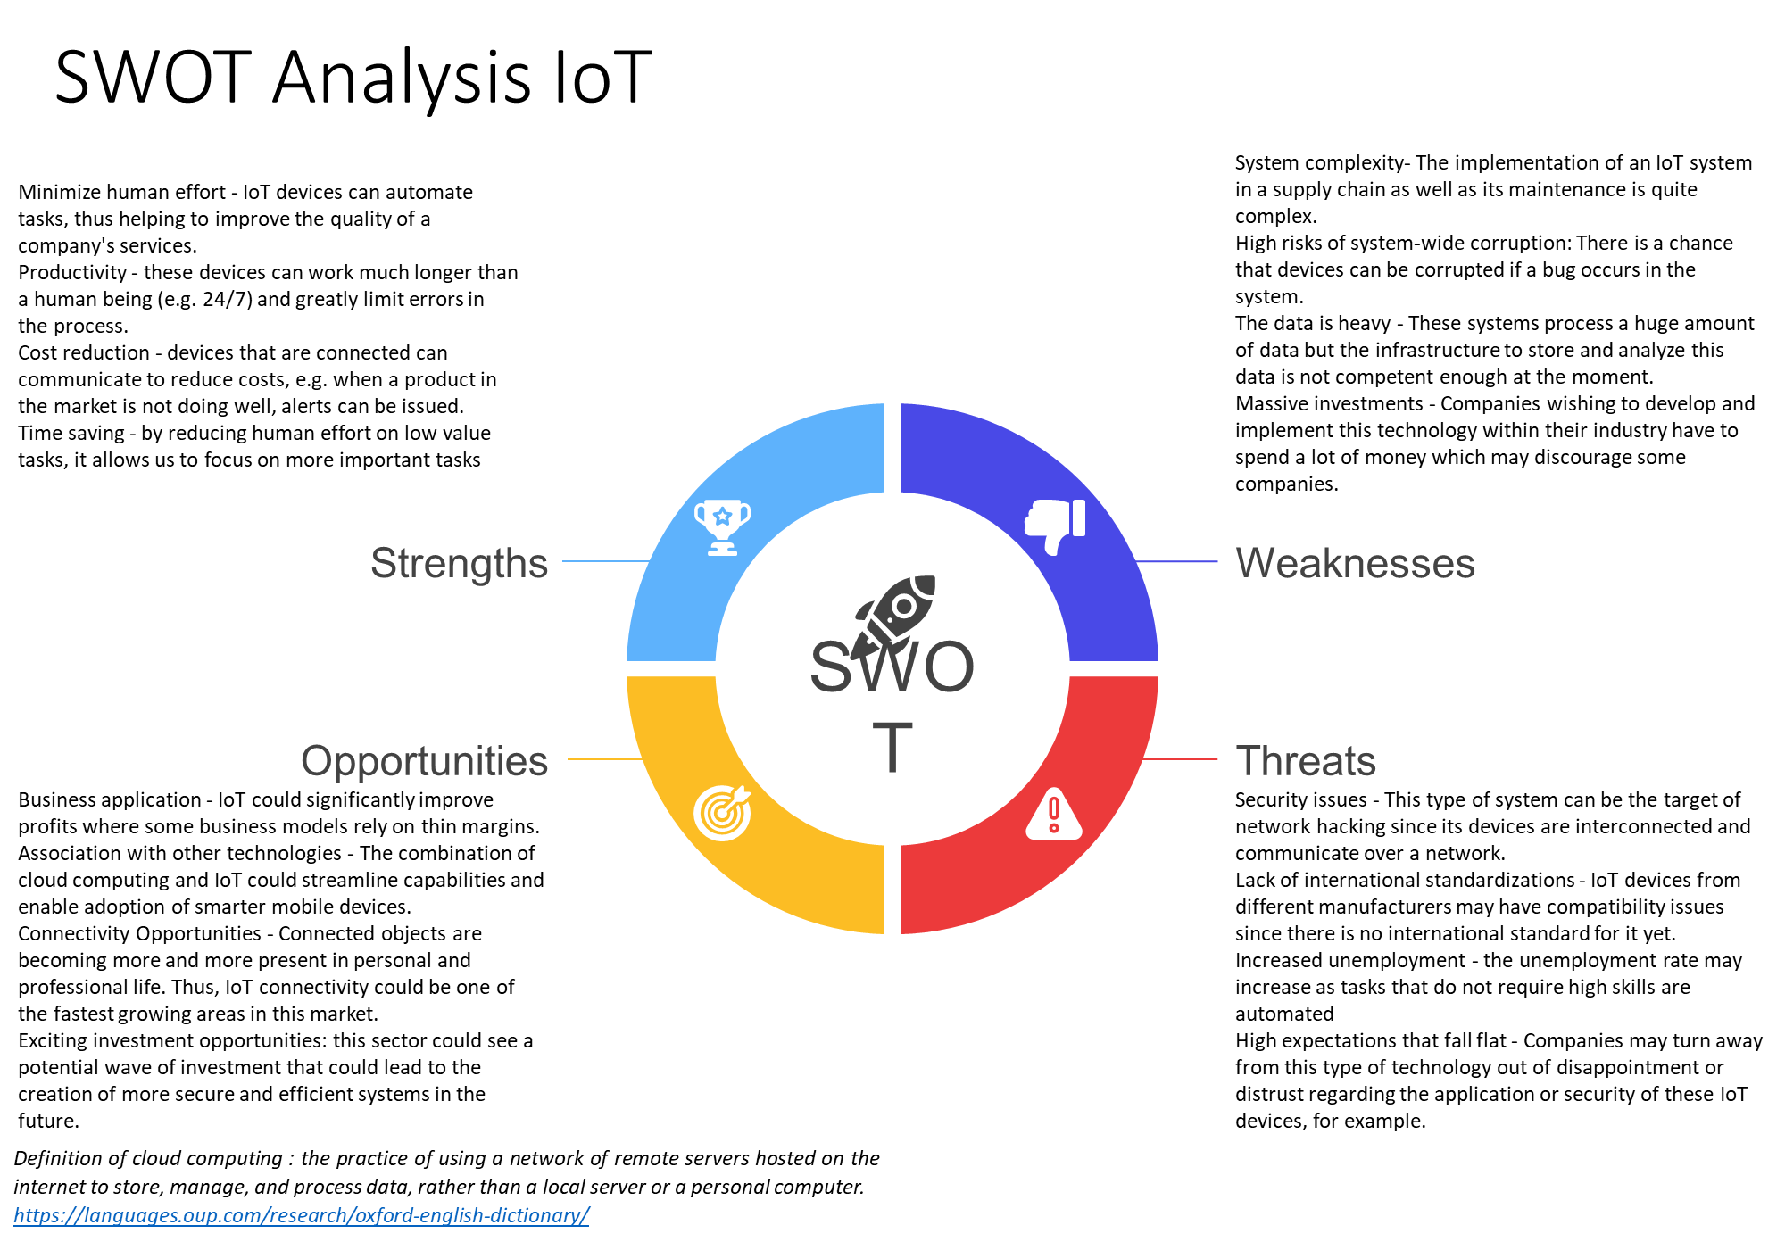

Figure 15 SWOT Analysis IoT

## 3.3 Artificial Intelligence

Figure 16 Gartners Model AI

### 

### 3.3.1 Basics of AI

Artificial Intelligence (AI) is a term representing the range of techniques that allow machines to mimic human intelligence.

5 different components of AI are:

* Learning
* Reasoning
* Problem-solving
* Perception
* Language-understanding.

AI can differ from chess opponents to chatbots to self-driving cars, so that indicates that it can be implemented on many different levels.

### 3.3.2 Three different types of AI:

* Artificial Narrow Intelligence (ANI) which is like stage 1 in AI learning and specializes in one area and solves one problem.
* Artificial General Intelligence (AGI) is stage 2 in AI where it has its intelligence, and it refers to a computer that is as smart as a human across the board.
* Artificial Super Intelligence (ASI) is stage 3 where the AI starts to get “consciousness” and is smarter than the best human brains in all fields possible.

The fields it’s being used in at this moment are Retail, shopping and fashion, security and surveillance, sports analytics and activities, and finally manufacturing and production. (Advani, 2021)

### 3.3.3 Examples of AI used nowadays

**Siri:** A familiar personal assistant for Apple users that can give information, directions, add events to our agenda, help us text someone or give a call, and much more. Siri is a pseudo-intelligent digital personal assistant that uses machine-learning technology to get smarter and be able to predict and understand the user better after finding out its ways of communicating.

**Tesla:**One of the best products on the market due to the use of technology, this car can drive itself and has the ability to much more sheer technological coolness. The car is getting smarter with every update that’s being done.

**Amazon:**The AI usage within Amazon has been there for quite some time already, allowing the site to make astronomical amounts of money online. The algorithms used are being more refined every year and amazon has gotten acutely smart in predicting our demand for products based on our interests.

**Netflix:**This company can provide entertainment at home with a highly accurate prediction technology based on the reactions of their customers to films. Also, a huge dataset is getting smarter with the years. The only downfall is that the preference of chosen movies by Netflix is mostly big-named movies which makes the small-labelled movies go unnoticed. (Adams, 2017)

### 3.3.4 Gartner Maturity Level

Different organizations use their AI differently as well. The Gartner maturity model segments the usage of AI within the companies into five different levels:  
Awareness, Active, Operational, Systemic, and Transformational.

Most AI systems are somewhere between the level of Active and Operational, the AI functions like intended but one key measure is still missing and that’s explainability. The complex underlying neuronal architectures are functioning and it’s clear that they have a layered way of working, but once it is outside of the AI scheme, there is where the trouble starts for AI.

So, therefore, AI is on a level 2 or 3 in most cases and the wide variety of usage in AI can conclude that it could also be a lower or higher level in some cases, but AI is called a mature technology these days. (Lamb, 2017)

## 3.4 Big Data

Just to give you an idea of what Big Data means: the term "Big Data" refers to data sets that are too large or complex for simple processing algorithms. The amount of data held within these sets is so big that traditional processing algorithms simply can't process it.

Data is defined as the quality characters or symbols on which operations are performed by a computer which may be stored and transmitted in the form of electrical signals. In short, we can say that all facts and figures that can be stored in digital form can be defined as data.

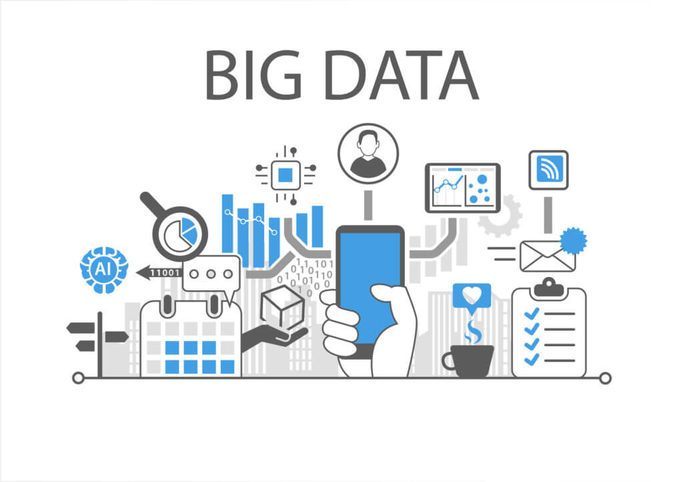

Figure 17 Big Data (Gavrailova, 2020)

Credit card companies get real-time data of when their credit card is being used and where it is being used. This data helps them in fraud detection, think of a credit card being used at a location for the first time then after three hours the same card is being used at location B which can be 10000 kilometers away from the location. In the current time, it is practically impossible for a person to travel 10000 kilometers in two hours and hence it becomes clear that someone is trying to fool the system.

This is just an example, big data has hundreds of different applications in hundreds of different fields banking, communication, healthcare, media, advertising, manufacturing, transportation, and retail bank. Data can be everywhere, and therefore more and more businesses are trying to harness its power. Classification is essential for the study of any subject, so big data is divided into three main categories: structured, unstructured, and semi-structured data.

### 3.4.1 Structured Data

***Structured data*** is used to touch on the data which is already stored in databases in an easy-to-understand method, it accounts for about 20% of all the acquired data and is being utilised in most of the programming and computer-associated activities. There are different types of structured data: machines, and humans. All the information received from sensors weblogs, and financial systems are categorised under machine-created data. Including production devices, geolocation data, user statistics captured on servers and apps. The huge amount of data that usually moves through trading platforms to name a few human-created structured data mainly contains all the data that humans put into computer systems. Such as names and other personal details when a person clicks a link on the Internet or even makes a move in a game data is created. This can be used by companies to figure out their customer’s behaviour and make the appropriate business decisions and modifications.

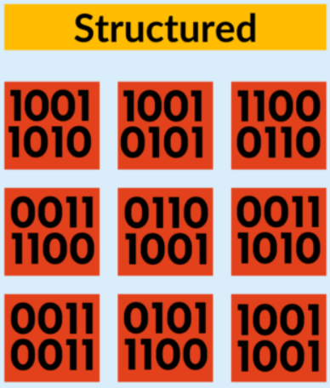

Figure 18 Structured Data (Allen, 2020)

### 3.4.2 Unstructured Data

***Unstructured data*** is the opposite, there is no set form in saving the data. The total unstructured data created in big data is about 80% of the whole. this implies that most of the created data is unusable without proper analysis. As mentioned before the majority belongs to the current category, with the current state of the technology before there wasn't much to try and do except store it or analyse it manually. Unstructured data is additionally classified based on its source: machine-generated or human-generated. Machine-generated data includes for instance the satellite images, scientific data from different tests, and radar data captured by different parts of the technology. Human-generated unstructured data is found everywhere on the net. All of this includes also the data from mobile, web, and social media content. this suggests the images we upload to Facebook or Instagram, the videos we watch on YouTube, and even the text messages we send. It all contributes to the gigantic keep that is unstructured data.

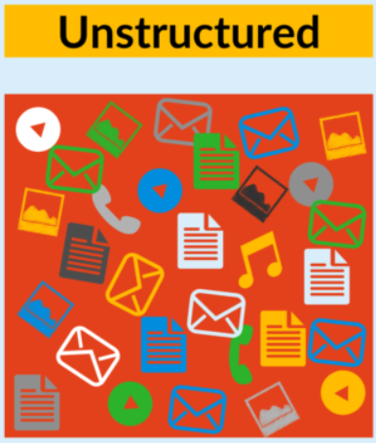

Figure 19 Unstructured Data (Allen, 2020)

### 3.4.3 Semi-structured Data

***Semi-structured data:*** The difference between unstructured data and semi-structured data can be quite difficult to conclude in many cases. This is because most of the data we get appears to be unstructured at first. The case with semi-structured data is that the information that is not in the database is structured data, but it does contain parts of the organizational properties, which in many cases makes it easier to process. For example, when looking at NoSQL documents, we can say that they are semi-structured since they contain keywords that can be used to easily process the document.

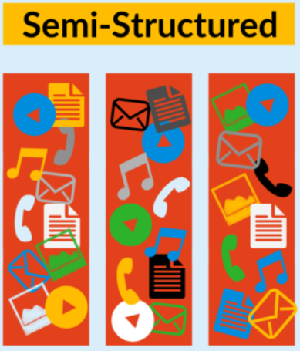

Figure 20 Semi-Structured Data (Allen, 2020)

### 3.4.4 How do we know that the data is big data?

Categorizing is possible with the following categories of five V’s: volume, velocity, variety, veracity, and value. To comprehend the topic better, we can take an example from the medical industry. For example, hospitals and clinics around the world generate lots of data. The data is collected in the form of patient records and test results. All the data is created at a very high pace which is part of the velocity category of big data. Variety refers to the various data types, such as:

* Excel files can be seen as Structured data.
* Log files can be seen as Semi-Structured data.
* Lastly, we can say the X-ray images can be seen as unstructured data.

The accuracy and trustworthiness of the generated data is termed veracity. Analysing this data will contribute to the sector by giving the opportunity and the possibility to detect diseases faster, higher quality of treatments, and cost reduction. This is also one of the contributions of big data to companies. We store and process this big data with various frameworks such as Cassandra, Hadoop, and Spark. If we look at Hadoop, we can see how Hadoop saves acquired data and the processing the given data. Hadoop system operates on a distributed system, which means that their files are split/ shared on other systems to be stored. This is also known as Hadoop distributed file system. A file with a big size will be split into smaller parts and saved on different devices/ servers. Splitting the documents into small parts will also allow you to make multiple copies of them which will also be saved in different nodes. With the method, you will be storing your data in a distributed way and make sure that even if one machine fails your data is safe on another.

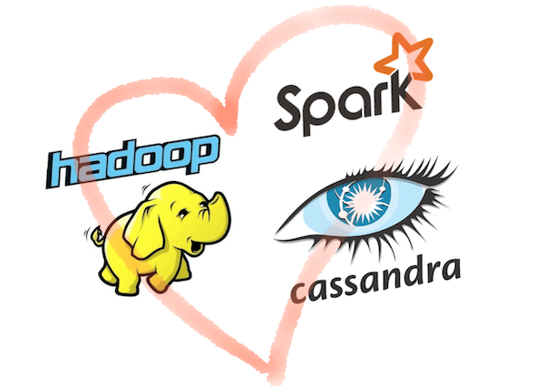

Figure 21 Hadoop Spark and Cassandra (Arjones, 2015)

Big data analysis has been found to have an important business value and its analysis. The processing of important data can help a company achieve cost reductions and dynamic growth. This makes the technology even more attractive, and essential to use for companies aiming to grow their business with analytical strategies.

### 3.4.5 Gartner’s Maturity Model & Swot Analysis

Looking at Gartner’s Maturity Model, we can see that the current state of big data is around the 4th and 5th levels. The main reason that it switches up between those levels is that the usage or utilization of big data differs in a lot of sectors. In its current state, we can give different examples on each level. For example, on the 4th level of this technology, we can see almost all the production companies use data to analyse the forecast and demand. This is mainly being done to optimise their inventory level, production, and reduce costs. In some situations, data can become one of the essences of the processes. This means that the companies use mainly data to adjust their services and their processes based on the acquired information. This part falls mainly under the 5th level of Gartner’s model. For example, in this category, we can mention the companies such as Netflix, Disney+, and Banks using big data to analyse the client relevant information. At this level, the data collected is heavily coming from the customer’s side.

Figure 22 Gartner’s Maturity Model: Big Data

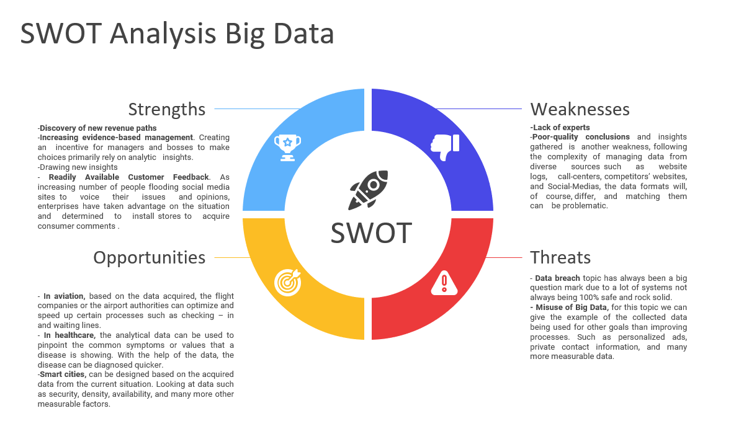

Figure 23 SWOT Analysis Big Data

## 3.5 API

API’s, aka Application Programming Interface, are parts of code that operate as a digital mediator between apps and digital systems. APIs can provide exposure for one application to another, enable interoperability between different systems, and provide a uniform language for programmers to communicate with one another. The use of APIs has grown exponentially in recent years as developers have harnessed their ability to create cross-platform apps and otherwise increase performance and productivity.

### 3.5.1 How do APIs work?

APIs work by allowing pieces of software to talk to other programs on machines they're not running on. For example, an API can make it possible for a user to log in on one application using their Facebook account, and then use that information to log into their email. APIs create the links that allow applications to communicate with one another.

To use the Facebook example again, say your bank wanted its users to have access to their accounts anywhere they were. Management could set up an API that allowed users to log in with Facebook, then link the data from Facebook with their financial information - all without switching accounts or websites.

APIs are mainly systems operating as service protocols for developers, who created an easy way of information sharing system instead of recreating every created system. Developers cooperate instead of fighting over information. APIs solve the sharing and cooperation problem that programmers never could have handled on their own.

The main drawbacks of APIs are the fundamental problems of locking resources together. The world is full of APIs and they're in everything, but they are not all great. There are poorly implemented APIs that can break apart a system or put security at risk, but there's also a spectrum of quality among them. For this reason, developers must take into account the quality and accessibility of a given API when deciding on whether or not to use it in their projects.

### 3.5.2 APIs in Supply Chain

The API enables a digital supply chain in which everything can be accessed from the inventory levels to the location of sending a product to the status of an order or payment in real-time. With increased access comes increased efficiency and more control over the supply chain process. Before AWS APIs, data had to be queried and aggregated manually, which could take days. Now, data is shared via an API, basically creating one Web service for businesses to connect with others online. These APIs can be accessed from almost any type of device if it has an Internet connection. This increased visibility and access to information means that suppliers can make one-time adjustments to orders, shipments, and payment terms more easily.

APIs used to be difficult to build; however, with advances in computer programming, companies have been able to create more robust APIs. APIs are more than just a way to call up data. An API is also a specification that describes how applications may interact with each other. The developer then builds an application that interacts with the API, resulting in a tool or solution which is likely to be used across many applications. This makes APIs the great equalizer for programmers because most of the programming that needs to be done for a new product or service can be automated by an API.

### 3.5.3 Business’ & API System providers

Businesses use APIs for a variety of reasons, including inventory status checking, order tracking, receiving payments, and tracking shipments. At its core, an API connects two apps so that they can communicate with each other without the need for human input or manual processing. Apps may exist within businesses themselves or between businesses to automate various processes. On the illustration on the next page, we can see the biggest players on the API market and development process.

* 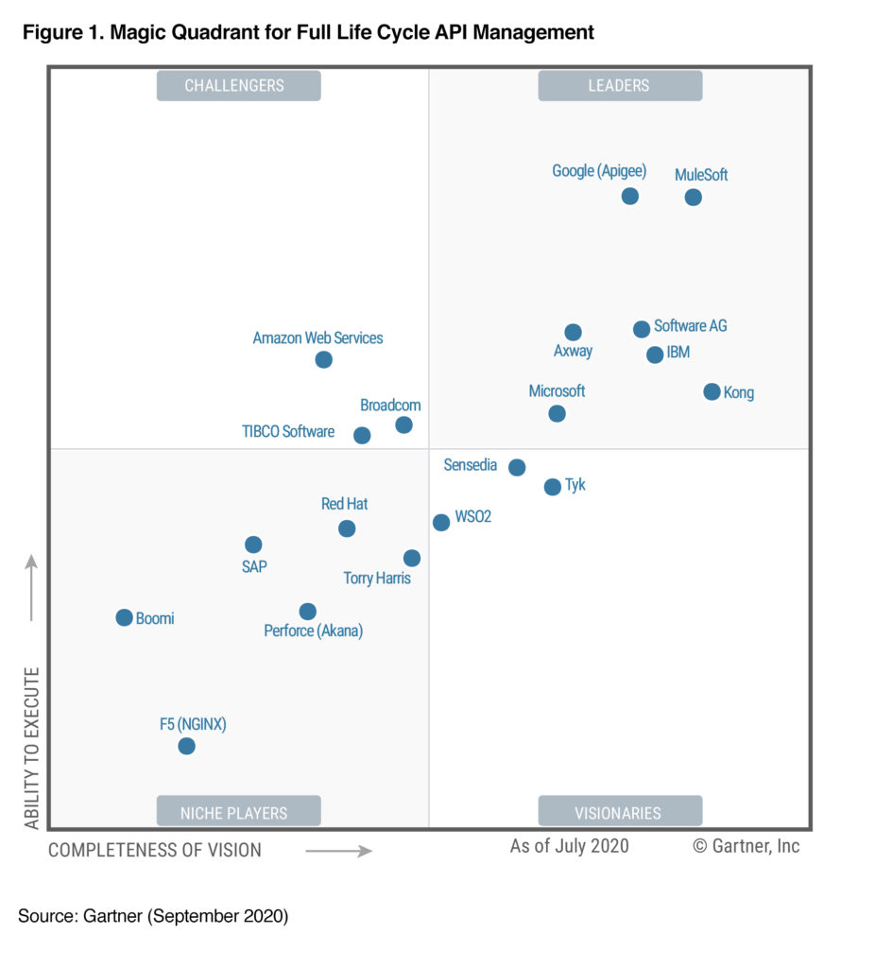Leading companies in the API systems sector are illustrated as followed:

Figure 24 API system Providers (Gartner, API SERVICE PROVIDERS' LEVELS)

## 3.6 Cloud Computing

The definition of Cloud computing can be described as followed: storing, accessing data and programs over the internet instead of your hardware. It is a pattern change from the traditional "server-based" method to a system that is built on a "client-server”. Your web browser, cell phone, tablet, etc., are all clients that connect to one or more servers on the Cloud.

Currently of information overload, cloud computing brings with it greater efficiencies in data storage and retrieval. More importantly, it lowers barriers of entry into new markets for small businesses due to its scalability in delivering cost-effective IT services without big upfront investment.

### 3.6.1 Benefits of Cloud Computing

Flexibility in usage and scalability -The web environment offers a degree of flexibility in usage not normally possible with the on-premises software model.

* Cloud computing allows both a company and an individual to access their data and applications from any location, anytime they want.
* It allows users to scale quickly by adding resources and storage space as the need arises, instead of having to purchase additional hardware at higher prices.
* Cloud computing also enables companies to lower IT costs by hosting their data not just on their servers or computers but on servers hosted by different providers.
* Cloud computing can be used to analyse or access information. Speeds are fast, and it is much easier than going through folders on your computer. For example, if you want to get more information regarding the product you order from the supplier’s website, you can do that in a matter of seconds; this is a definite advantage of cloud computing.
* Cloud computing offers improved data storage systems so there is less damage to your data and records if something happens on your computer system or devices, such as an accidental deletion or virus attack.

### 3.6.2 Cloud Computing in Supply Chain

For supply chains, cloud computing provides limitless possibilities. Outsourcing various functions to cloud providers can save retailers time and resources while giving them unprecedented visibility into their operations. While this isn't a one-size-fits-all solution for every company's business problem, it is worth exploring as much as possible if you need help keeping up with demand or require more extensive analytical capabilities like no other system provides.

For example, when you buy a product from a store, there is a process that needs to take place from the time it reaches the manufacturer to the point of purchase. Cloud computing is an online service provided by providers and suppliers. It has become one of the most important tools for many companies.

### 3.6.3 Summary

The world of cloud computing systems supply chain is rapidly expanding and becoming very popular in every industry as well as for DIY (Do-It-Yourself) projects. Many companies utilize this method for their business and internal database storage. With the help of the cloud computing systems supply chain, companies can move away from IT and server management. Instead, the responsibility is now put on a third-party cloud service provider. Cloud computing is changing how businesses operate and will continue to change how companies handle storage, data security, online collaboration and other business aspects. Companies are quickly realizing that this technology can be used to their benefit in many ways.

The cloud computing systems in the supply chain is a blessing for big businesses with multiple needs for access to data at once. Having a system being accessible from everywhere by just having an internet connection has a hugely positive effect on their processes which is paying them back in form of profit and a higher grade of control in their processes. In the illustration down below, you can see what different levels of cloud computing includes. For a broad description look at the attachments.

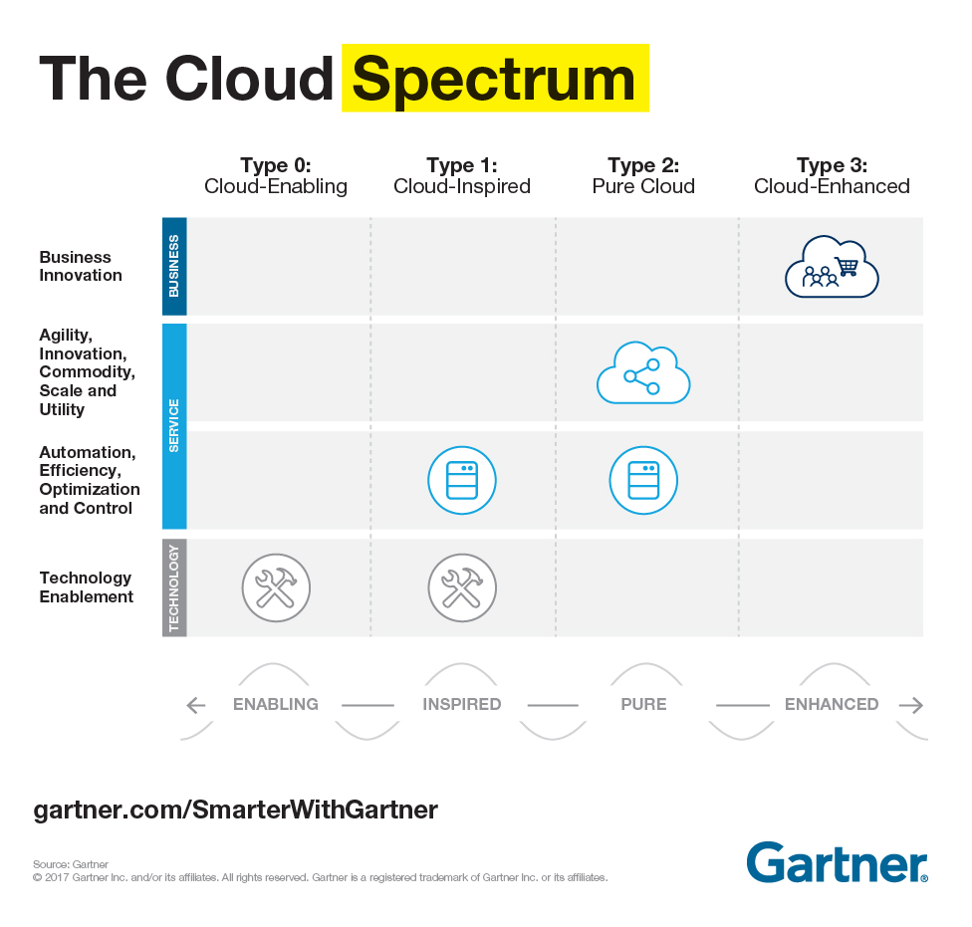

Figure 25 The cloud spectrum model (Gartner, The Cloud Spectrum)

# 4 Use Cases

4.1 Walmart & Blockchain Implementation 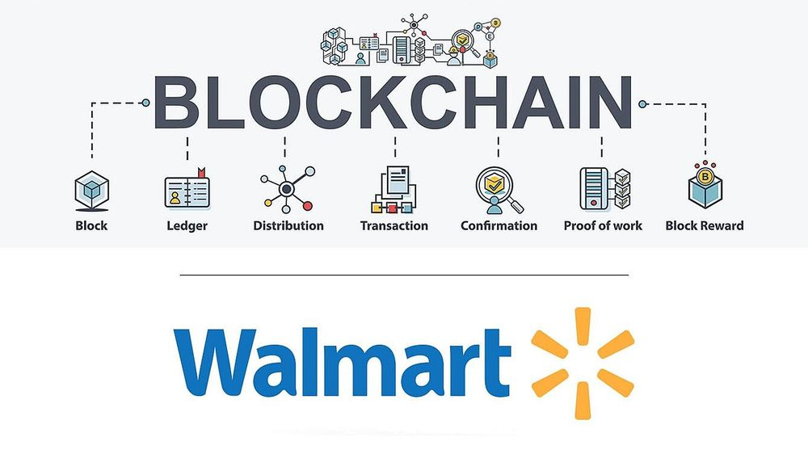

Figure 26 Walmart & Blockchain (Walmart)

### 4.1.1 Case summary

If we look at this case, it is mainly about Walmart trying to implement a blockchain system to make their processes seamless and transparent but also trackable. “Walmart has opened thousands of stores in the U.S. and expanded internationally. Through innovation, they are creating a seamless experience to let customers shop anytime and anywhere online and in stores. They are creating opportunities and bringing value to customers and communities around the globe. Walmart operates approximately 10,500 stores and clubs under 48 banners in 24 countries and eCommerce websites. They have 2.2 million associates employed around the world — nearly 1.6 million in the U.S.” (Walmart, 2018) The problem itself was that the traceability in the food supply chain was inefficient and taking way too long to find out which party delivered the lower quality of food. In this subject, we will explain how Walmart worked together with IBM to find a solution to reduce the times for searching the cause and create a transparent process.

For detailed information read the case below.



### 4.1.2 The challenge

When a foodborne illness breaks out, it can take days, if not weeks, to find the cause. Better traceability could help save lives by allowing businesses to act faster and protect farmers' by only discarding products from affected holdings.

### 4.1.3 The situation before the implementation of Blockchain

Before the implementation of blockchain, Walmart was working manually which meant for them to register the information on papers or poorly integrated software systems. This way of working leads to inefficient registration of information and data. Having the data and the information not structured in a way that is easier to trace back leads to longer times in search for causes in the food supply chain. When we look at the tracking and traceability of the foods in the situation before, we can say that the times to trace the origin of the product would take days if not weeks in some cases. As a more specific example, we can say that the average tracking & tracing for mangos is approximately 7 days in the United States of America. Another problem the situation before the implementation was that the processes grew up rapidly that the incoming information also increased. This increase led to more errors due to the available time that the employees had to handle the incoming data and information. Also, next to this problem a different problem occurred regarding the manpower. The company had trouble with being undermanned.

### 4.1.4 The situation after the implementation of Blockchain

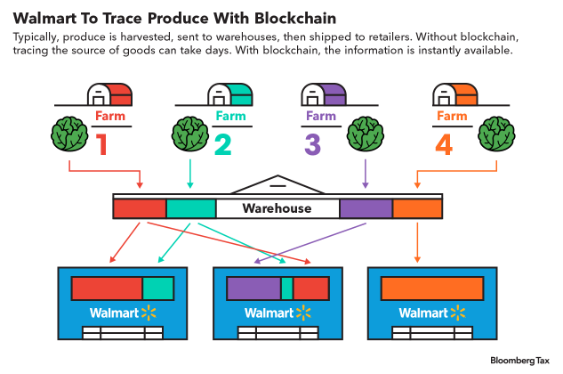

Figure 27 Walmart Farms & System

After the IBM experts and the process engineers of Walmart designed a blockchain system, they implemented the system into their processes. The goal of the implementation did not only consist of raising the traceability of the products that come in and out to the markets but also adding more transparency to their process. This meant every supply chain partner was able to access the same information on the system. This was possible due to registering every transaction on the system in a way to make it clearer, faster, and easier to work with. The implementation of this process took Walmart approximately 11 months (October 2016 – August 2017) to implement the system on one product to test and improve the process. After the first implementation, they have seen quite a big improvement regarding tracking and tracing. As we have mentioned before, the average time to trace the origin of mango was approximately 7 days. After the implementation, it got reduced to 2.2 seconds. This meant that the process went approximately 860 times faster than normal. After seeing and measuring this improvement Walmart decided to implement the system on other products as well. By the end of September 2018, Walmart has implemented over 25 products and 5 suppliers to improve their supply chain.

### 4.1.5 Conclusion:

When we look at the learning goals from this case, we can list them as below:

* In this case we have noticed that Walmart has started with a pilot. They took the time to measure the process and improve it for the better by experimenting with the system. After fully understanding and fixing the flaws they scaled the process.
* By designing and implementing such a system, Walmart has shown that every company should be benefiting from the growth in technology to increase their productivity and their responsibility within the society.
* As we have seen in the case, Walmart has put their scope sharp enough to make a precise change in their process to enhance their productivity and work efficiency.

## 4.2 Disneyland Case

### 4.2.1 Summary of the case:

The current case is about Disney wanting to enhance the customer experience and improve their services. To achieve this goal, they used different systems in the past. For instance, Disney launched the Fastpass service in 1999. It is an improvement for the customer to get faster their favourite attraction. In 2011, they expanded the Fastpass ticket to other services in their attraction park (World Disney World at Orlando). In the same year, Disney launched a new high-technology project called “NextGen”. That means the customers can book time for what they want to see in the park such as attractions, restaurants, hotels, shows, etc. even before leaving their house. As a follow-up to the NextGen project, Walt Disney introduced a management app system named MyMagic+. The goal of this application is to end the traditional practices that are not value-adding for the process. As mentioned before, that system speeds up the process such as payments, reservations, etc. As an addition to the MyMagic+ app, they implanted Magic bands. The goal of this Magic band is an input device for the sensors. The Magic Bands are made for rubberized plastic bracelets. Those bracelets use RFID to communicate with other sensors to register data provided by the customers.

The Magic Bands were designed to create an experience for the customer to travel lighter. Meaning that the customers did not have to carry any paper tickets or credit cards. This feature also eliminated the situations where the tickets get damaged or lost by the clients. Another added value for this implementation is that the family can stay together with the whole since the system is operating and being used online. Also, as an addition, the app offered free plan changes without charging the customers any costs. After seeing the success in Orlando, the company decided to expand its services to four theme parks and two water parks. By expanding their services & systems, Disney used their customer’s input as a sample to collect data. With this data, Disney aimed to also personalize the customer-specific ads and shopping. This strategy leads to a growth of 6% in profit in its first year of implementation. The gross cost of the implementation in the parks is being mentioned as 1 billion dollars for the system only, as in addition, they mentioned the costs to train 60.000 employees being added on top of the price mentioned before.

In the text, there is also being mentioned that the system has a couple of downsides. If we were to mention them shortly, we can list them as followed: the quality of design for the bracelets. It is being told that the bracelet becomes irritating and sweaty during the customer’s time in the park.

Apart from the design, the other downside of this implementation was the privacy concern from the customer. Many of the users were concerned about how the collected data would be used and for how long it would be saved in the companies’ servers.

Another downside to mention is that not every user of the bracelet can understand the technology. The reason can be that the user is an older adult or a younger child. In some cases, this can create frustrations and ruin the joy for a minor group of customers.

At the end of the case, Disney is taking conclusions and explaining how they want to continue in the future with their MM+ & Magic Band project. It is being mentioned that the company is still in a testing phase with their project even though they implemented MM+ & Magic Band in multiple other parks. During this Beta phase, Disney wants to collect as much data as they can to improve and optimize the system.

### 4.2.2 The challenge

The challenge for Disney is mainly focused on improving the customer experience by gathering more information about their visitors and reducing the non-value adding traditional processes.

### 4.2.3 The situation before the MM+ implementation

One of the first changes that Disney made was in 1999. The system they implemented was Fastpass. This allowed people to buy tickets to bypass the long waiting lines. However, this improvement was on paper just like the previous traditional processes. The traditional processes are as followed: a process to prove your identity, waiting in line on buying a paper ticket, paying with cash & with a credit card in the park, buying different tickets for different activities, and no option to reserve a seat on a show or attraction.

When we look at the process of proving your identity while buying a paper ticket, we can see that the customers might need to bring extra documents to show it in the beginning. This leads to carrying more papers and documents. By carrying those documents, you will have a high chance of losing them during your time in the park, not only losing them but also damaged tickets might not allow you to use many other services in the park. This situation will create enormous frustration and many costs for the customers to renew their documents. Also, this process will be wasting the time of the customer to replace their tickets in which they will have a “bad” experience in the park. As mentioned before and in this case, the customers had to buy multiple different tickets to make use of different services inside the park. Those services being the shows, attractions, and meetups with some Disney characters. By making the customer buy multiple different tickets, the process is putting more paper documents in the travel bag of the customer. This leads to a greater risk of incomplete or damaged paper tickets for the visitors. Along with that point, this is also putting more pressure on carrying more documents which will be a burden in some cases for the customers.

The next part is about the use of cash and credit card within Disneyland. If we look at the situation before, we can see that the customers had to carry cash or credit cards to make payments inside the park. Having to carry payment instruments also brings some risk with it. We can list some of the risks as followed:

* Losing credit cards
* Pickpocketing
* Damaged cash (by attractions with water etc.)

Those risks have a quite high chance to occur. As a result of these events, the customer experience is being influenced badly.

The other point that has been mentioned in the case is that the customers must wait in queues to buy their paper tickets since they could not receive them online. This process leads to some long queue times but also frustration since the customer must arrive “earlier” to reserve time for this process. Aside from this part, the customer did have partially the option to reserve their tickets but still needed to wait in the queue to claim them. Another point that was mentioned is that the customer did not have an option to reserve spots in their favourite shows and attractions. Due to them not being able to reserve a spot in those shows, sometimes the visitors had to wait longer in queues to be lucky to have a spot on the time that they wished. Which in many cases lead to wasting more time in waiting lines for the shows and attractions.

### 4.2.4 The situation after the implementation

#### 4.2.4.1 IoT

After two test phases, they have implemented a new system in their process based on Big Data and Internet of Things technology. The goal of this investment is to have only the value-added steps in the process and to improve the customer experience. Based on the IoT aspect, the management system in the theme park is called the MyMagic+ system. This system includes my Disney Experience website, a mobile application, MagicBands, and a touchpoint(sensor). As stated in the presentation of the information-sharing technology called IoT, “*hardware can be classified into general devices and sensing devices. The general devices are the main components of the data hub and information exchange.* *Sensing devices include sensors and actuators.*” In our case, the main device is the MagicBands bracelet, and the sensing device is the sensor named touchpoint.

MagicBands can be thought of as an electronic ID card for each visitor during their visit to Disney Park. MagicBands are rubber wristbands that incorporate microchips. These chips function as radio frequency identification (RFID) transmitters that can share data over a 2.4 GHz spectrum. With this technology, the wristbands can be read by both short- and long-range readers. Specifically, they can communicate with Disney computers and allow users to access all features related to their Disney activities.

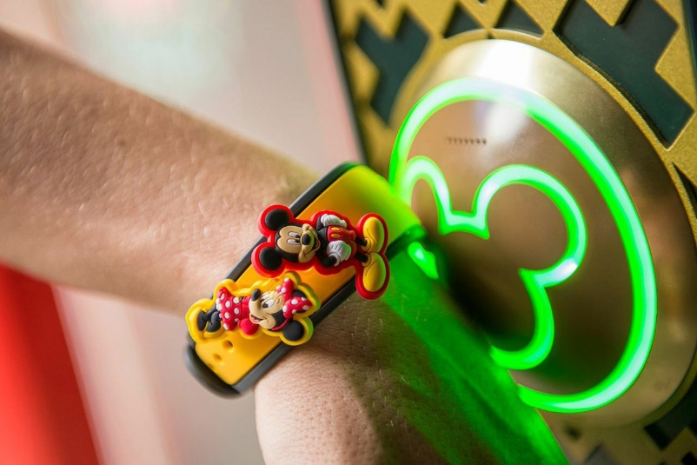But in concrete terms, how does it work? We can imagine that we are in the attraction park, and we have a MagicBand. We decide to go to an attraction and before entering the attraction we have to bring the bracelet against a sensor called a touchpoint.

Figure 28 Disney Magic Band & Touchpoints (Disney)

At the level of an individual guest, this generates information collected by Disney indicating the identity of the user and the attraction he is about to enter. These touchpoints are located in places such as the doors of resort rooms, theme parks, water park entrances, etc. At the group level, it has more impact because as mentioned before, the sensors are distributed throughout the parks and generate huge amounts of data on the movements of each customer. This data is already being used by Disney's operations team to dynamically improve the customer experience. For example, this data may indicate that a group of guests is waiting in a long line for a ride. In response, suggestions are made by the Disney team in real-time to encourage guests to move to less crowded areas of the park (KO, 2019). Thanks to this breakthrough, the park's logistics is optimized, and this generates enormous value, i.e., an increase in customer satisfaction (they consume more) and more efficient use of resources.

4.2.4.2 BIGDATA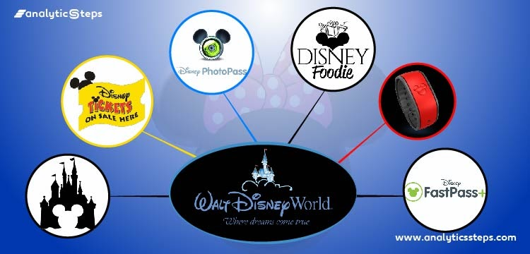

Figure 29

The newly implemented system in the Disney case allows them to track their customer’s behaviour within the parks. The goal of this implementation is to mainly gather data about each customer to be able to bring up customer-specific ads and suggestions. Not only ads or suggestions, but also aimed to forecast, analyze the data, and make innovations. To register the data, Disney used multiple different sensors such as RFID scanners, proximity sensors, accelerometers, infrared sensors, and image sensors. With the help of those sensors, Disney is registering a tremendous amount of data in their system about each client. If we look more specifically at what kind of information is being registered, we can mention it as followed:

* Proximity sensors are simply measuring the number of people on an attraction and certain spots in the parks. The information that those sensors read is being used to see if there can be adjustments and improvements at those locations.
* By using accelerometers Disney is measuring the vibrations and the intensity of the attractions in their parks. The registered data is being processed to see what the intensity is on the attractions and when the maintenance should be planned in to make planning more efficient. By planning efficiently Disney can reduce the downtime of their attractions and increase the operational time of an attraction to satisfy the visitors with more availability.
* As mentioned before the RFID scanners are working in combination with IoT. The RFID scanners are mainly used for scanning the tickets and scans during the payment process. Those sensors are simply connected with the server to get the right client information to register and use the information to make certain processes convenient for the visitors. The information can be that when a client makes a purchase, and the bracelet registers the transaction to demand payment after from the customer’s bank. Some of the other steps can be explained as follows: The system will get the necessary client information from the bracelet after being scanned by the RFID sensor. This information is partially registered beforehand by the client or by the MyMagic+ system. The information is also being registered by the client’s behaviour in the park. Meaning the purchases they make, the attractions they use, and the locations they have been within certain times are being recorded in the system to bring up tailored offers for each customer.

Other than the sensors mentioned before, Disney is also using a system to take pictures of their clients while using an attraction. The goal of this sensor is to mainly simplify the process of accessing your picture after the ride. With the newly implemented system, Disney is saving the picture and submitting it in the app to you. We can see that the system is registering your location in a different way than GPS operating systems but still being functional at its highest level.

If we look at how Disney is using Bigdata to its advantage, we can list the following points. They:

* Drive operational efficiency with a data-driven approach
* Transform the client experience by using an analytical approach and wearable technology.
* Thrive to more custom-tailored experiences.
* Amplify the effect of technology by using multiple different digital tools.

### 4.2.5 Conclusion:

If we summarize the use case of the Disney theme park, we could mention the main points below:

* The goal of this breakthrough was to streamline the process steps and improve the customer experience.
* In this case, we have observed that Disney has made previous studies before rolling out their new process. Basic versions of this system had been established and experimented on a small group of customers by creating a playground.
* Implementing this system has given the possibility to anticipate the expectations of people by tracking and tracing.
* There are also some difficulties with this implementation as we read through the case. It has been mentioned a couple of times that the company had to educate their employees and implement on multiple different locations which also lead to extra financial expenses. Meaning that the implementation was costly than expected.
* Another challenge or a breakthrough was the privacy of each customer. In this matter, Disney ensured to his customers that the data collected would handle with care and at most safety. By ensuring the client, the system was operating accordingly to their expectations. With the trust of their customers, they continuously improved their processes, services, systems.
* The biggest quality of Disney’s way of improving their processes and services is that they are heavily focussed on customer satisfaction. They are thinking more about the customers rather than the process. This means that they are following the customer intimacy strategy. In the end, when we take a look at the numbers after the implementation, we can see a growth of 7% in the profit margin and satisfied visitors due to the convenience of the service.

# 5 The end conclusion of the project

In conclusion, this school project we have conducted focused on finding applications using data-sharing technologies in supply chain and logistics. This project allowed us to become familiar with technologies that we knew the name of because of the hype around them but had no knowledge about how they work. We also provided SparkLivingLab with deliverables such as articles for companies wanting to implement these technologies in their supply chain.

There are several data-sharing technologies available on the market today for companies looking to implement these systems in their supply chain. The focus was on those with the greatest potential today and soon namely Big Data, Cloud Computing, Blockchain, Internet of Things, and Artificial Intelligence. Today, it is very difficult for companies to choose technologies. They have no idea about the added value that these technologies can create because of the lack of information. Researching these technologies allows us to realize the potential and the impact they can have on the industry. However, the combination of technologies often proves to have the most significant impact in terms of supply chain improvement. This has been verified in case studies, notably between the combination of the Internet of Things and cloud computing or big data (Disneyland use case).

In general, all of these technologies have commonalities regarding their use in industry, namely making the process more transparent, more seamless, streamlining the steps in the supply chain, and limiting those that do not add value. But to achieve this result, several criteria must be taken into account. First of all, the implementation of this technology requires to have well-defined the problem that this technology must solve. For example, Walmart identified that it had a supply chain tracking problem that was inefficient and time-consuming if the company encountered problems with its food. So, implementing Blockchain simply allowed them to deliver better quality products to their customers. Another important point is the company's ability to think about how to adapt the chosen technology to its supply chain. The Port of Rotterdam, for example, has worked with IBM to adapt and implement technologies such as Big Data and IoT devices to improve the management of container doors and containers in the port. In addition, this thinking about how to implement technology is always accompanied by a testing phase. Regarding Walmart, the company has started tracking one type of vegetable with Blockchain. Seeing the improvements that the new system brought, a generation was made on several consumer products. As for Disney and their theme park, their new system (combination of Big Data and IoT devices) was tested on a small group of people in one park before being generalized. All this implementation is not done in one day. All the cases used have shown that there is a certain lapse of time between the reflection and the final phase. For example, the whole implementation of the Blockchain system for Walmart took almost a year. Note that this was only done for one product. Walmart waited another year to expand it to other products. Another thing to keep in mind is the financial investment that can be very important for a company. For example, Disney has invested more than a billion dollars in the implementation of Big data, the Internet of Things but also in the training of the staff to use this new system. Finally, the purpose of the use of these data-sharing technologies is to be kept in mind when a company wants to launch itself in this field. Indeed, the main goals are the improvement of the customer's experience like the Disneyworld Park and the improvement of the quality of the products as Walmart can show it.

Finally, indeed, the level of maturity is not quite the same from one technology to another. There is still a lot of room for improvement before we reach a maximum level of maturity for these technologies. This simply means that there is still a lot to be explored for each of them so that they are 100% reliable and can be used to their full potential in the industry and especially in the supply chain. What is striking is the efficiency and productivity that these technologies can bring to a company when they are intelligently associated with each other.

# Bibliography

Allen, R. (2020, September 22). *What are the Types of Big Data?* Retrieved from Selecthub: https://www.selecthub.com/big-data-analytics/types-of-big-data-analytics/

Arjones, G. (2015, October 12). *Making Hadoop 2.6 + Spark-Cassandra driver play nice together*. Retrieved from Arjon: https://arjon.es/2015/making-hadoop-2.6-spark-cassandra-driver-play-nice-together/

*Blockchain Implementation Walmart.* (n.d.). Retrieved from Inecta : https://www.inecta.com/hs-fs/hubfs/Block%20Chain%20Walmart.jpg?width=1338&name=Block%20Chain%20Walmart.jpg

Disney. (n.d.). https://www.wired.com/2015/03/disney-magicband/.

Dughi, P. (2018, January 4). *A simple explanation of how blockchain works*. Retrieved from Medium: https://medium.com/the-mission/a-simple-explanation-on-how-blockchain-works-e52f75da6e9a

Ethan. (2017, April 22). *EXCLUSIVE: MagicBand touch points upgrades revealed; coming to Disney soon?* Retrieved from MagicBands Collectors: https://www.magicbandcollectors.com/exclusive-magicband-touch-points-throughout-disney-getting-a-technical-upgrade-soon/

Explained, S. (2017, November 13). *How does a blockchains work?* Retrieved from Youtube: https://www.youtube.com/watch?app=desktop&v=SSo_EIwHSd4&feature=youtu.be

Gartner. (n.d.). *API SERVICE PROVIDERS' LEVELS.* Gartner.

Gartner. (n.d.). The Cloud Spectrum. *The Cloud Spectrum.* Gartner, Online.

Gavrailova, G. (2020, January 8). *Définition du Big Data : qu’est-ce que c’est et comment ça marche ?* Retrieved from Mailjet: https://fr.mailjet.com/blog/news/big-data-definition/

Hamblen, M. (2018, May 3). *Port of Rotterdam on course for self-driving ships by 2030*. Retrieved from SmartCitiesWorld: https://www.smartcitiesworld.net/special-reports/port-of-rotterdam-on-course-for-self-driving-ships-by-2030

IBM Industries. (2019, November 12). *The Extra Mile: Port of Rotterdam*. Retrieved from Youtube: https://www.youtube.com/watch?app=desktop&v=0L6AScZwnw0

KO. (2019, November 13). *Big Data Behind Disney Magic* . Retrieved from Digital HBS: https://digital.hbs.edu/platform-digit/submission/big-data-behind-disney-magic/

Oukrich, N. (2019, April). *Daily Human Activity Recognition in Smart Home based on Feature Selection, Neural Network and Load Signature of Appliances*. Retrieved from ResearchGate: https://www.researchgate.net/publication/334695831_Daily_Human_Activity_Recognition_in_Smart_Home_based_on_Feature_Selection_Neural_Network_and_Load_Signature_of_Appliances

Simplilearn. (2020, August 24). *IoT - Internet of Things | What is IoT? | IoT Explained in 6 Minutes | How IoT Works | Simplilearn*. Retrieved from Youtube: https://www.youtube.com/watch?app=desktop&v=6mBO2vqLv38

Walmart. (2018, June 17). *about.* Retrieved from Coorporate Walmart: https://corporate.walmart.com/about

Walmart. (n.d.). *Blockchain Walmart.*

Writer, P. C. (2021, November 1). *What Is Distributed Ledger Technology (DLT)?* Retrieved from Phemex: https://phemex.com/academy/what-is-distributed-ledger-technology-dlt

Zilverline. (2020, October 21). *Internet of Things*. Retrieved from Zilverline: https://www.zilverline.com/software-ontwikkeling/internet-of-things

# **Attachments**

## Attachment 1 Articles



## Attachment 2 Extra Cases



## Attachment 3 Proof of Concept



## Attachment 4 Technology Providers List

  
Attachment 5 Preliminary Research



# **Figure List**

[Figure 1 Blockchain Model (Dughi, 2018) 5](https://liveadminwindesheim.sharepoint.com/sites/O365-SparkLivingLabs/Gedeelde%20documenten/General/Final%20Report%20Files/Spark%20Living%20Lab%20End%20Report%20-%20v0.1.docx#_Toc93092708)

[Figure 2 Blockchain Model (Dughi, 2018) 5](https://liveadminwindesheim.sharepoint.com/sites/O365-SparkLivingLabs/Gedeelde%20documenten/General/Final%20Report%20Files/Spark%20Living%20Lab%20End%20Report%20-%20v0.1.docx#_Toc93092709)

Figure 3 The Properties of Distributed Ledger Technology (DLT) (Writer, 2021) 6

[Figure 4 Informations included in a block (Explained, 2017) 7](https://liveadminwindesheim.sharepoint.com/sites/O365-SparkLivingLabs/Gedeelde%20documenten/General/Final%20Report%20Files/Spark%20Living%20Lab%20End%20Report%20-%20v0.1.docx#_Toc93092711)

[Figure 5 Link between blocks (Explained, 2017) 7](https://liveadminwindesheim.sharepoint.com/sites/O365-SparkLivingLabs/Gedeelde%20documenten/General/Final%20Report%20Files/Spark%20Living%20Lab%20End%20Report%20-%20v0.1.docx#_Toc93092712)

[Figure 6 Peer to peer network (Explained, 2017) 8](https://liveadminwindesheim.sharepoint.com/sites/O365-SparkLivingLabs/Gedeelde%20documenten/General/Final%20Report%20Files/Spark%20Living%20Lab%20End%20Report%20-%20v0.1.docx#_Toc93092713)

[Figure 7 Everyone possess the data (Explained, 2017) 8](https://liveadminwindesheim.sharepoint.com/sites/O365-SparkLivingLabs/Gedeelde%20documenten/General/Final%20Report%20Files/Spark%20Living%20Lab%20End%20Report%20-%20v0.1.docx#_Toc93092714)

Figure 8 SWOT Analysis Blockchain 11

Figure 9 IoT Model (Zilverline, 2020) 12

Figure 10 Iot in the house (Oukrich, 2019) 12

Figure 11 IoT devices (Simplilearn, 2020) 13

Figure 12 IoT and automatic soil watering (Simplilearn, 2020) 14

Figure 13 IoT in the industry (Hamblen, 2018) 14

Figure 14 Examples of sensors in the port of Rotterdam (IBM Industries, 2019) 15

[Figure 15 SWOT Analysis IoT 16](https://liveadminwindesheim.sharepoint.com/sites/O365-SparkLivingLabs/Gedeelde%20documenten/General/Final%20Report%20Files/Spark%20Living%20Lab%20End%20Report%20-%20v0.1.docx#_Toc93092722)

[Figure 16 Gartners Model AI 17](https://liveadminwindesheim.sharepoint.com/sites/O365-SparkLivingLabs/Gedeelde%20documenten/General/Final%20Report%20Files/Spark%20Living%20Lab%20End%20Report%20-%20v0.1.docx#_Toc93092723)

Figure 17 Big Data (Gavrailova, 2020) 19

Figure 18 Structured Data (Allen, 2020) 20

Figure 19 Unstructured Data (Allen, 2020) 20

Figure 20 Semi-Structured Data (Allen, 2020) 21

Figure 21 Hadoop Spark and Cassandra (Arjones, 2015) 22

Figure 22 Gartner’s Maturity Model: Big Data 23

Figure 23 SWOT Analysis Big Data 23

[Figure 24 API system Providers (Gartner, API SERVICE PROVIDERS' LEVELS) 25](https://liveadminwindesheim.sharepoint.com/sites/O365-SparkLivingLabs/Gedeelde%20documenten/General/Final%20Report%20Files/Spark%20Living%20Lab%20End%20Report%20-%20v0.1.docx#_Toc93092731)

[Figure 25 The cloud spectrum model (Gartner, The Cloud Spectrum) 27](https://liveadminwindesheim.sharepoint.com/sites/O365-SparkLivingLabs/Gedeelde%20documenten/General/Final%20Report%20Files/Spark%20Living%20Lab%20End%20Report%20-%20v0.1.docx#_Toc93092732)

Figure 26 Walmart & Blockchain (Walmart) 28

Figure 27 Walmart Farms & System 29

[Figure 28 Disney Magic Band & Touchpoints (Disney) 33](https://liveadminwindesheim.sharepoint.com/sites/O365-SparkLivingLabs/Gedeelde%20documenten/General/Final%20Report%20Files/Spark%20Living%20Lab%20End%20Report%20-%20v0.1.docx#_Toc93092735)

Figure 29 34